**Homepage**

**IVC (instead of ICVPME)**

**The international valuation conference**

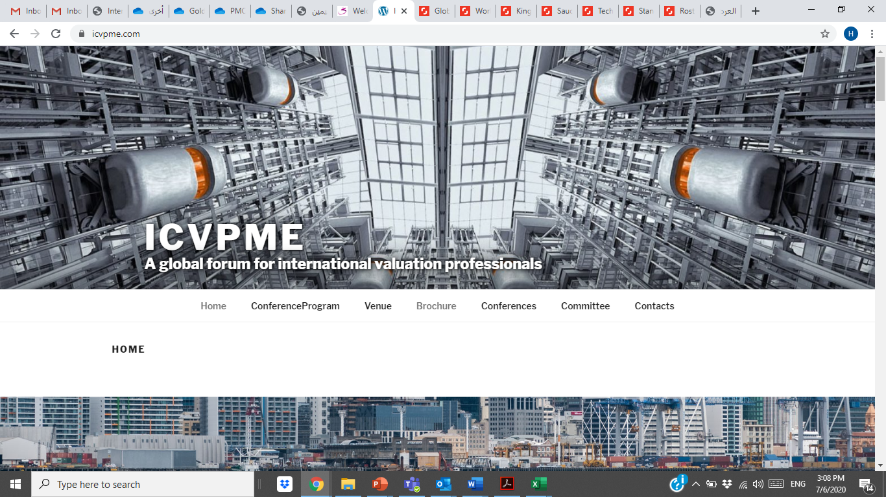**A Global Exchange of Valuation Knowledge**

* **إضافة تعداد تنازلي بالأشهر (حتى تاريخ 26 سبتمبر 2021)**
* **إضافة الفيديو التعريفي للمؤتمر**
* **إضاقة المعلومات أدناه:**

**26,27,28 September 2021**

**Riyadh, Saudi Arabia**

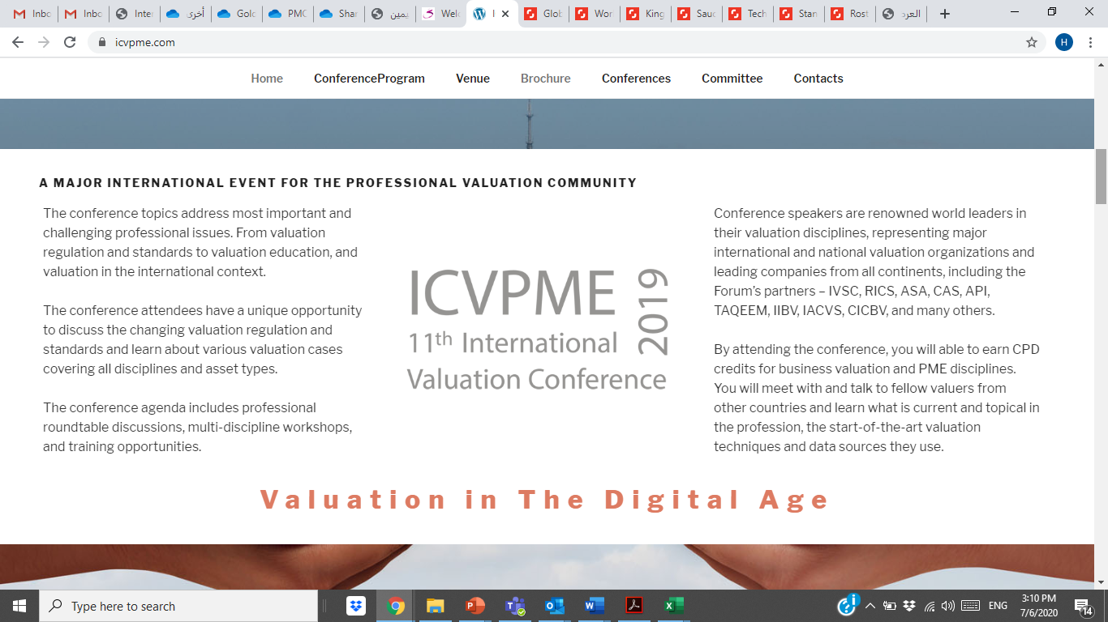

**A MAJOR INTERNATIONAL EVENT FOR THE PROFESSIONAL VALUATION COMMUNITY (remains the same)**

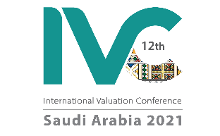

**New logo:**

**The Future of the Profession (instead of "valuation in the digital age")**

**About**

**The International Valuation Conference “IVC” (formerly known as ICVPME) is held biennially in different locations around the world to connect valuation professionals, experts and practitioners to discuss important topics and latest trends and updates on the profession.**

**The IVC is a multi-discipline conference which aims to provide opportunities for local and international valuers, enhance knowledge exchange and enable professionals to share their experiences and opinions.**

**The conference topics will address important and challenging professional issues focusing on the future of the profession. The agenda will include professional roundtable discussions, multi-discipline workshops, and training opportunities for the conference attendees.**

**By attending the conference, you will able to earn CPD credits for all the valuation disciplines. You will meet and connect with professional valuers from major international and local valuation organizations and leading companies from all around the world.**

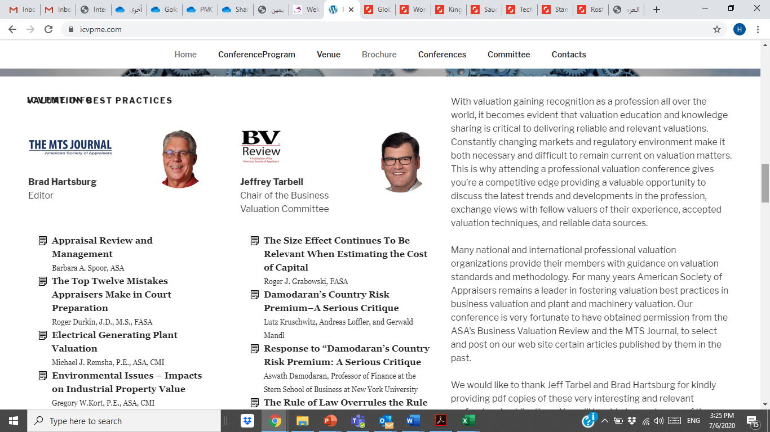**(remains the same)**

**Speakers & Topics**

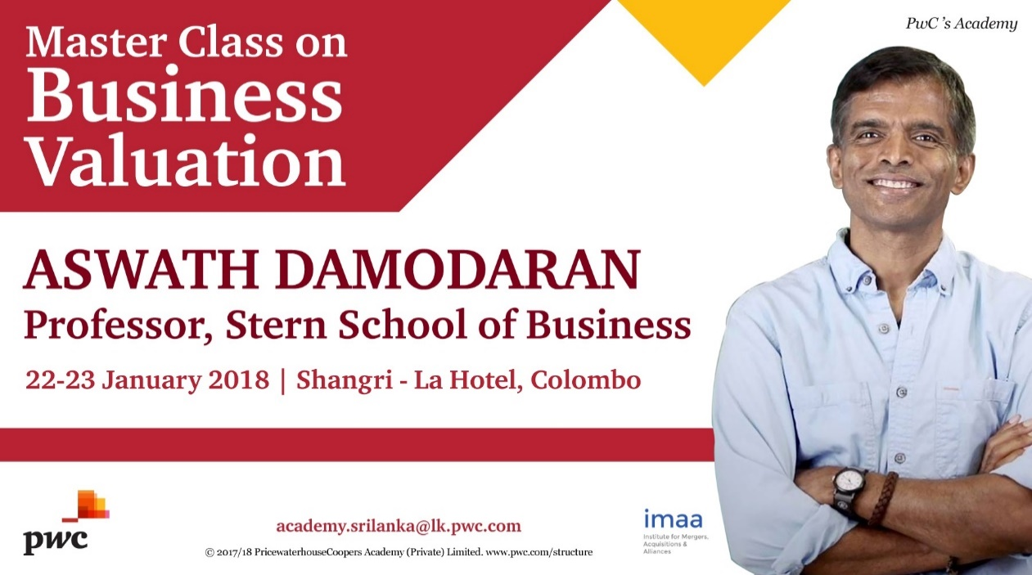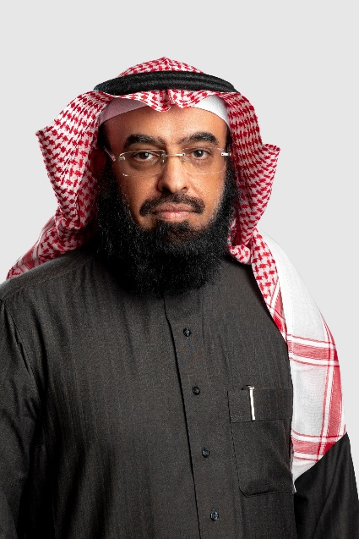

Soltan Aljorais

Johnnie white

Aswath Damodaran

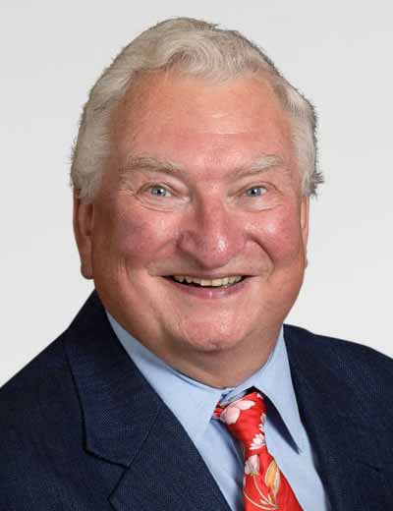

Roger Grabowski

Jeffrey Tarbell

**To learn more about the Conference, download the conference brochure in English, Arabic, Chinese and Russian. (remains the same without links)**

**Our Supporters**

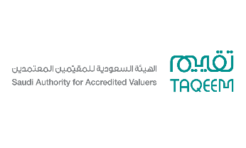**إضافة شعار الجهة ورابط الموقع والنبذة**

TAQEEM

<https://www.taqeem.gov.sa/index_en.php>

Saudi Authority for Accredited Valuers (TAQEEM) is the regulator of the valuation profession in Saudi Arabia. Taqeem works on implementing laws and legislations which allows valuers to practice the profession according to the International Valuation Standards (IVS). Taqeem also provides training courses which accredits and qualifies practitioners based on international practices. Valuation contributes in preserving rights and achieving justice through providing professional services and high-quality valuation reports. Because we believe in promoting trust and transparency in the market as well as creating an attractive investment environment in alignment with the Saudi vision 2030, we have chosen "Trust in Value" as our slogan.



ASA

<https://www.appraisers.org/Home>

The American Society of Appraisers is a multi-discipline, non-profit, international organization of professional appraisers representing all appraisal disciplines: Appraisal Review and Management, Business Valuation, Gems and Jewelry, Machinery and Technical Specialties, Personal Property and Real Property. Our mission is to foster the public trust of our members and the appraisal profession through compliance with the highest levels of ethical and professional standards.

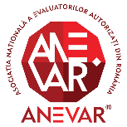

ANEVAR

<http://site2.anevar.ro/pagini/home>

ANEVAR (The National Association of Romanian Authorized Valuers) was regulated in 2011 by the Government Ordinance No. 24/2011 on asset valuation, as approved with amendments by Law No. 99/2013.  ANEVAR is a professional not-for-profit organization with public utility which includes all authorized valuers in Romania. The main purpose of ANEVAR is to organise, coordinate and authorise the way in which professional valuers work in this country, as well as to represent and protect professional interests of its members.

**Conference Program page**

|  |  |
| --- | --- |
| **Day 1: Sunday**  26th of September 2021 | |
| 8:00 am – 9:00 am | Registration & Welcome Reception |
| 9:05 am – 10:00 am | Session 1 |
| 10:05 am – 11:00 am | Session 2 |
| 11:05 am – 12:00 pm | Session 3 |
| 12:00 pm – 12:45 pm | Break |
| 12:45 pm – 1:45 pm | Session 4 |
| 1:50 pm – 2:50 pm | Session 5 |
| 2:55 pm – 3:55 pm | Session 6 |

|  |  |
| --- | --- |
| **Day 2: Monday**  27th of September 2021 | |
| 9:00 am – 10:00 am | Session 1 |
| 10:05 am – 11:00 am | Session 2 |
| 11:05 am – 12:00 pm | Session 3 |
| 12:00 pm – 12:45 pm | Break |
| 12:45 pm – 1:45 pm | Session 4 |
| 1:50 pm – 2:50 pm | Session 5 |
| 2:55 pm – 3:55 pm | Session 6 |
| 8:00 pm – 10: pm | Gala Dinner |

|  |  |
| --- | --- |
| **Day 3: Tuesday**  28th of September 2021 | |
| 9:00 am – 10:00 am | Session 1 |
| 10:05 am – 11:00 am | Session 2 |
| 11:05 am – 12:00 pm | Session 3 |
| 12:00 pm – 12:45 pm | Break |
| 12:45 pm – 1:45 pm | Session 4 |
| 1:50 pm – 2:50 pm | Session 5 |
| 2:55 pm – 3:55 pm | Session 6 |
| 4:00 pm – 4:15 pm | Conference Closing & Announcements of the Next IVC |

**Venue page**

**(replace all information with the below)**

**Hilton Riyadh Hotel & Residences**

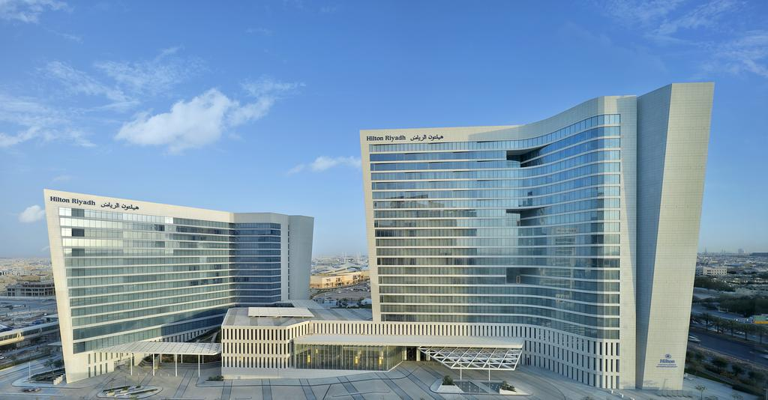

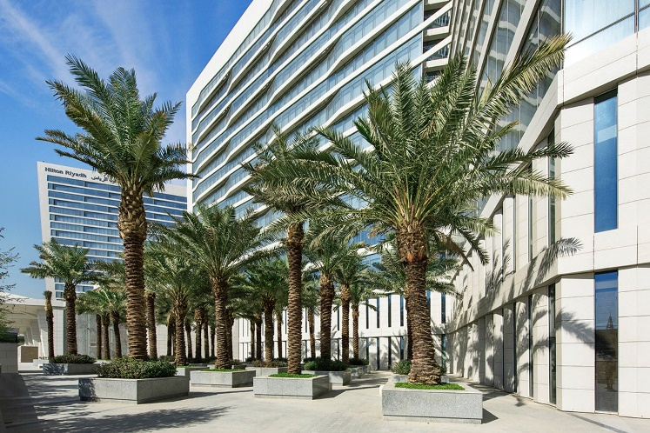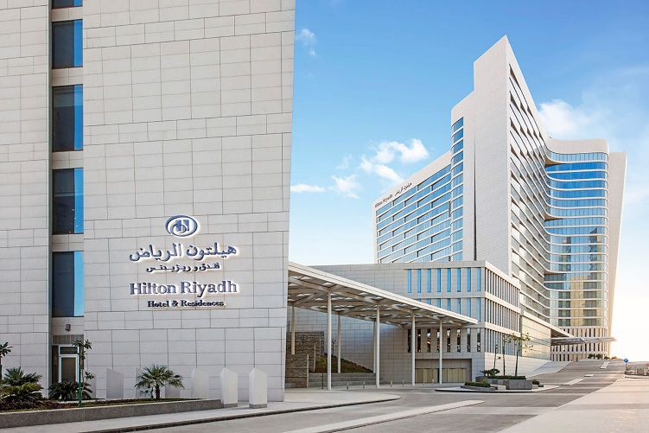

**The 12th IVC will be held at Hilton Riyadh Hotel & Residences in Riyadh, Saudi Arabia. The hotel's event venues include the largest pillar-free ballroom in the Middle East, private entrances, boardrooms etc. It has a total event space of 10,561 sq. m. and includes 23 meeting rooms as well as 866 guest rooms. It is located approximately 20–30 minute drive from King Khaled International Airport.**

**Location**

**(as a map)**

<https://www.hilton.com/en/hotels/ruhchhi-hilton-riyadh-hotel-and-residences/>

**Riyadh Customized page**

**صفحة مخصصة لمؤتمر الرياض**

**Visit Saudi بعنوان:**

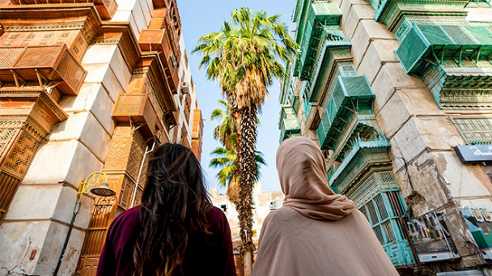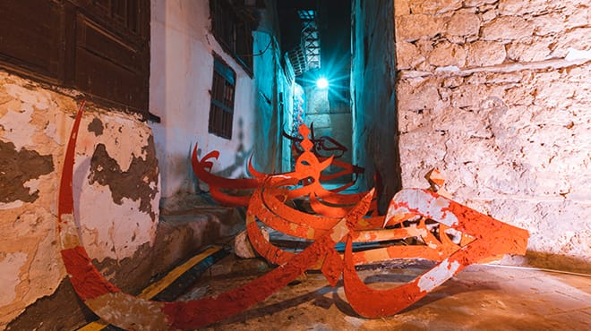**إضافة الصور أدناه**

**Language**

Arabic is the official language of Saudi Arabia and the primary language used in all dealings and public transactions. English serves as an informal second language in the Kingdom and is spoken by a large section of its society. All road signs are bilingual, showing information in both Arabic and English.

**Culture**

Saudi Arabia’s rich heritage and traditions have been shaped by its position as a historic trade hub and the birthplace of Islam. In recent years, the Kingdom has undergone a significant cultural transformation, evolving century-old customs to fit the contemporary world we live in today.

**Currencies & Payments**

Saudi Arabia’s national currency is the Saudi riyal (ر.س SAR).   
All banks in the Kingdom offer currency exchange services. Exchange bureaus are located at airports, some shopping centres and various other locations in the country. The US dollar is equivalent to SAR 3.75 (fixed rate). Credit cards, such as Visa, MasterCard and American Express are accepted throughout the Kingdom. ATMs are also widely available.

# Laws & Etiquette

* Both men and women are asked to dress modestly in public, avoiding tight-fitting clothing or clothes with profane language or images. Women should cover shoulders and knees in public.
* Public displays of affection are not consistent with local culture and visitors should also avoid using profane language or gestures.
* The sale, purchase and consumption of alcohol are illegal in Saudi Arabia. It is illegal to bring alcohol or drugs into the country.

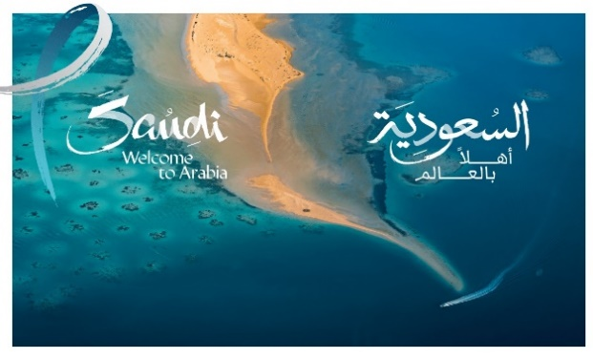

# About the tourist visa (E-visa)

Saudi Arabia is opening its doors to visitors from all over the world with a new entry visa regime in place from 27th September 2019. Tourists will obtain a multiple-entry visa valid for a year that will allow them to stay in the country for up to 90 days.

The new visa system is a historic milestone in opening Saudi Arabia to tourism. International visitors will discover the warm hospitality of Saudi people: our rich heritage, vibrant culture, and diverse and breath-taking landscapes, from the mountains of Abha to the beaches of the Red Sea and the shifting sands of the Empty Quarter.

**Visa Eligibility**

Tourists from eligible countries can apply for a tourist visa online through our fast and easy-to-use e-Visa portal ([https://visa.visitsaudi.com](https://visa.visitsaudi.com/)) ahead of their trip, or upon arrival in Saudi Arabia through visa kiosks at immigration. Tourists from other countries should apply for a consulate visa through Saudi embassies and consulates.

# Registration process

Applying for a tourist visa to the kingdom of Saudi Arabia is easy. If you are from one of the 49 eligible countries, you can apply through the e-Visa website. Other countries need to apply through their nearest Saudi embassy or consulate.

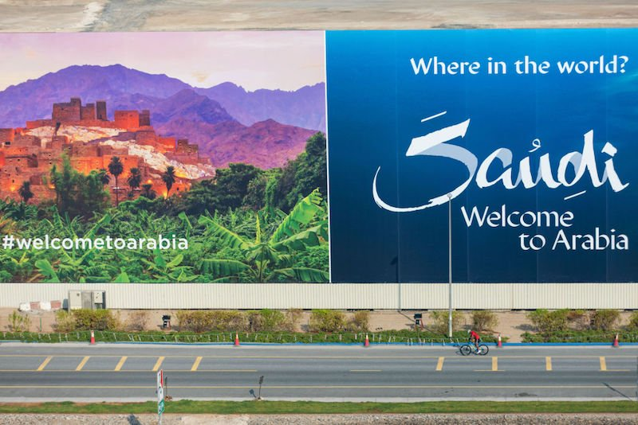

**Getting Around & Useful Contacts**

# Car rentals

Hiring a car is an efficient and cost-effective way to explore Saudi Arabia and visit the country’s many tourist attractions. Cars can be rented at airports, or in most cities, making it easy to get out and explore.

# Taxis

Taxis in Saudi Arabia are easy to find, particularly around busy locations such as shopping malls, hypermarkets and public parks. All are equipped with a digital meter detailing the fare, together with information on the driver and operating company. Some hotels offer cars for private hire too.

# Using Ride-hailing Apps

A number of ride-hailing apps operate in the Kingdom, including Uber and Careem. Just tap in your pick-up and drop-off locations and track your driver’s arrival online. Payment can be made either by cash or credit card.

*\*In the case of any issue or problem do not hesitate to call 938*

# Telephone code & providers

* Saudi Arabia’s country code is **00966.**
* There are three mobile network providers in Saudi Arabia: **STC**, **Mobily** and **Zain**

**Visit Saudi**



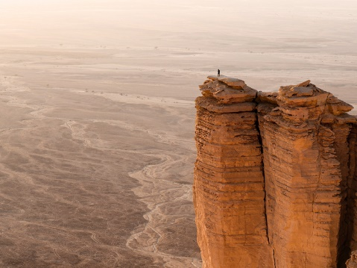

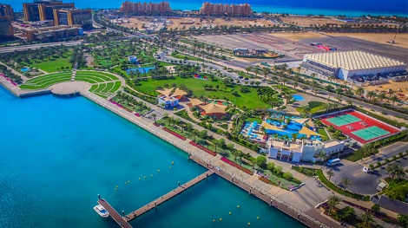****

Here’s everything you need to know about visiting Saudi Arabia.

Link to website: <https://www.visitsaudi.com/en>

* All media & information on this page are from Visit Saudi's website.

**تعديل كافة الصور في الموقع (الصور مرتبه بحسب ترتيبها في الموقع)**

**الصورة السابقة**

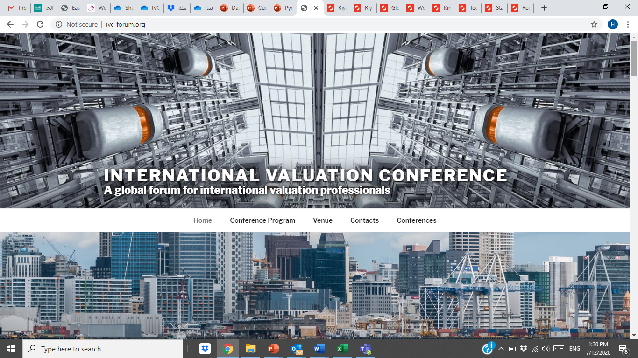

**الصورة الجديدة**



**الصورة السابقة**

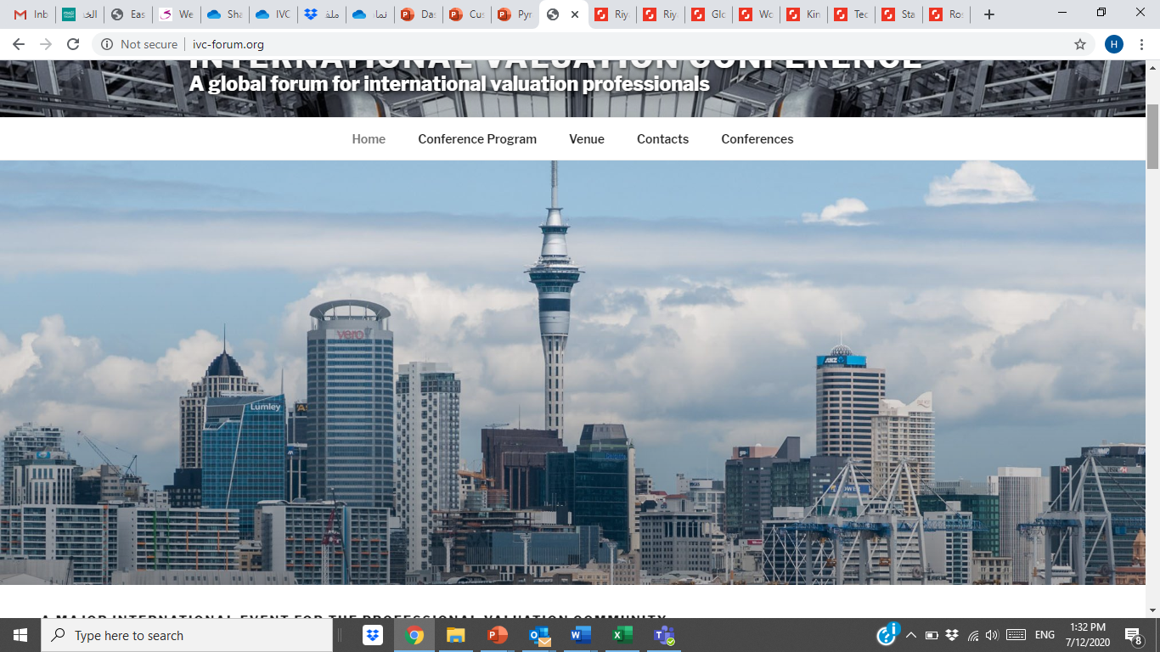

**الصورة الجديدة**

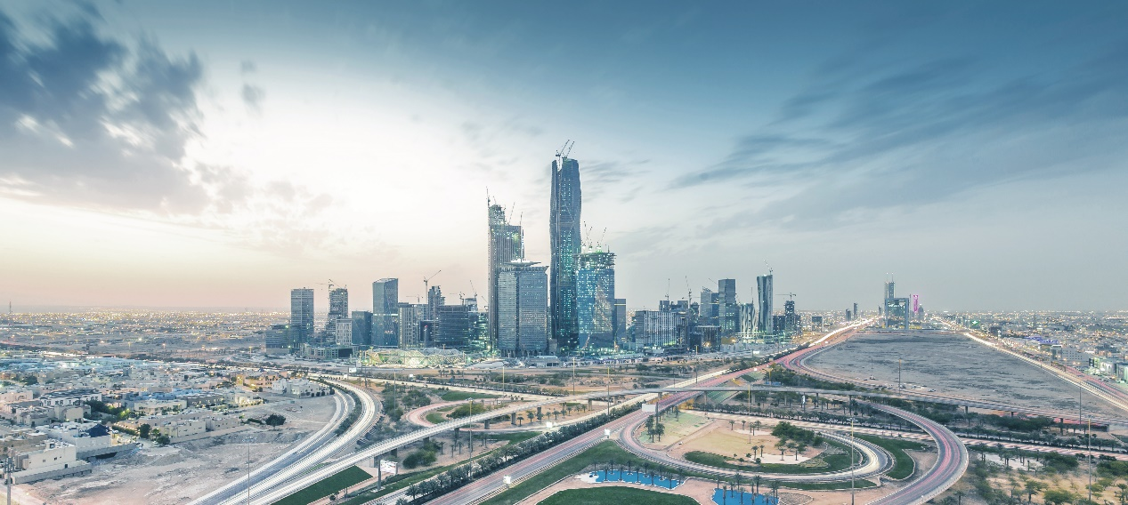

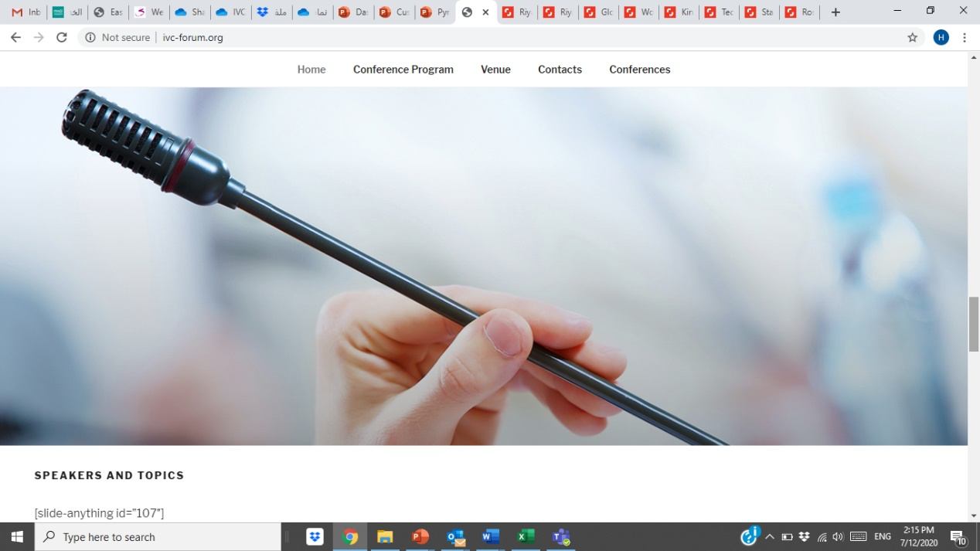**الصورة السابقة**

**الصورة الجديدة**



**الصورة السابقة**

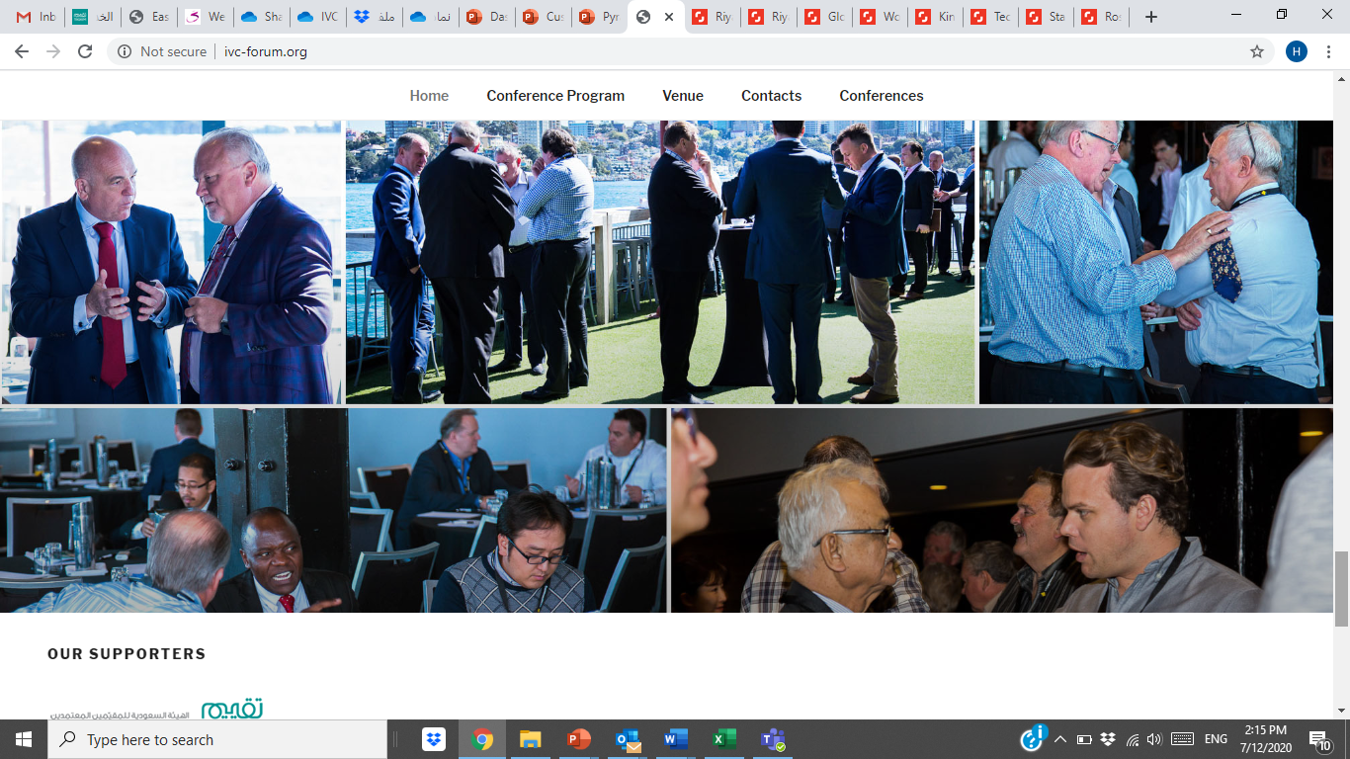

**الصورة الجديدة**

**تكون صف من الصور**

**هل نقدر في وورد بريس نخليهم رمادي وإذا مر عليها الماوس يصير لونها مختلف؟))**

